Whirlygirl Redesign Layout Ideas – March 9, 2006

Layout Diagram and Descriptions | The diagram and table below illustrate and describe the potential layout for the new whirlygirl.  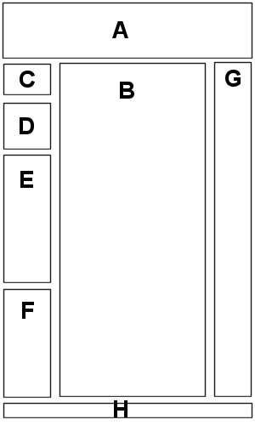
Continued on next page
Whirlygirl Redesign Layout Ideas – March 9, 2006, Continued

Layout Diagram and Descriptions (continued)

Letter | Area | Description
A | Logo and tagline | New logo and tagline; perhaps the tagline changes more frequently—but it does not have to.
B | Daily posts | A place for the blog posts. Each post has a title and date and will be tagged with the most appropriate categories (B, marriage, house, Todd/Hayley, etc.). I believe each post will have the ability to link to it individually and also leave/view comments [Question: Am I asking for trouble or what?].  All marginal posts (in my ears, on my TiVo, etc.) will be converted into posts with just shorter entries and tagged with the consistent title (“in my ears”).  Each month’s white rabbit winner will be converted into posts and then tagged as white rabbit. We can provide more dialogue about the winner (text from the email, asterisks, etc.)
C | About/Contact | I’d like to write a short “about” blurb that describes who I am, what I’m writing about, and the history of whirlygirl. Also a link to my blurb about contacting me—my explanation of why I never email people back—and a link to my email address.
D | Daily photo | Link to Flickr?
E | Recent Posts | A summary of links to the 5-8 most recent posts.
Continued on next page
Whirlygirl Redesign Layout Ideas – March 9, 2006, Continued

Layout Diagram and Descriptions (continued)

Letter | Area | Description
F | Archive/Search/ Browse Categories | The ability to view all of the archived posts either by  - browsing chronologically  - searching on specific keywords [Question: Can these be based on any text within the entry or only on metatags? If only on metatags, it may be redundant with the next bullet], or  - browsing the list of metatag categories.  Note: Until we get everything converted, this may also contains links to WG 1.0 through 5.0.
G | Google AdSense | Space for ads; google, etc.
H | Footer | A footer that contains name; copyright info (not really copyrighted, but you know); any necessary techie links. I would like this to visually tie in with the header.

